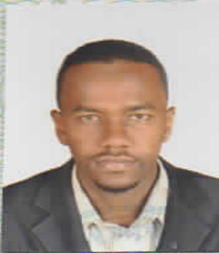

Personal details

Name: Hassan Eltayeb Osman Ahmed
Nationality: Sudanese.
Gender: Male
Date of Birth: 5th of August 1990
Marital Status: Single.
Address: Alhajyosuf, Bahri - Khartoum

Mobile Number: +249-123445608/+249-912529119
Email Address: Mstnk7@gmail.com
Languages Proficiency: Arabic Native Language, English very good (speaking & writing), French (basic).
Education

- Master’s degree, Clinical Pharmacy
Omdurman Islamic University (OIU)
(V.good Grade), March 2015
- Bachelor's degree, Pharmacy
Omdurman Islamic University (OIU)
Faculty of Pharmacy - July 2012
(Second class – Division two)
Work & experience
- Pharmacist at Sharq Al-Nile hospital.
- Director of Taiba Cancer Center pharmacy for the period from (1/12/2014) till (1/7/2015).
- Community pharmacist at Alfarooq group of pharmacies from 1st of June 2014 to 30 of November 2014.
- Pharmacist at the Military hospital (Clinical pharmacy department) from 21st of May 2013 to 20th of May 2014.
- Community pharmacist at Alfarooq group of pharmacies from 1st of December 2012 to 19/5/2013.
- Provisional (training) period at Albangadeed teaching hospital from 5/8/2012 to 5/11/2012.

Membership

- Registered as Clinical Pharmacy specialist at Sudan medical council under the number 655.
- Full registration at Sudan medical council as pharmacist under the number 10800.
- Member of Sudanese Society of Clinical Pharmacists
Skills and activities

- Excellent interpersonal communication skills.
- Work well under pressure.
- Flexible, initiative, take quick decision and inspire others.
- Knowledge of contemporary hospital pharmacy practice and services including integration of clinical services, distributive services, education and research activities.
- Self motivated.
- Good computer skills.
- Attending Sudanese Society of Clinical Pharmacists master classes of Nephrology and Ischemic heart diseases.

